Nama : Dodi Imron, Niko Ahmad Fauzi

NIM : 1127050044, 1127050117

Kelas : IF-B

**Component & Deployment Diagram**

1. **Component**

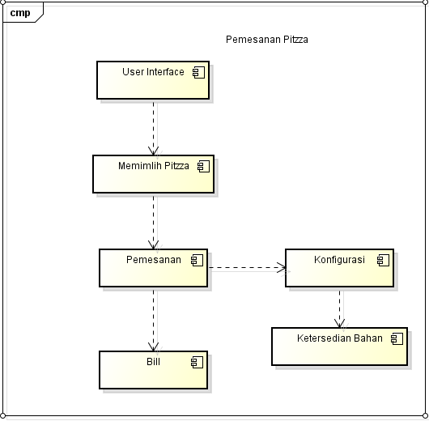

1. **Deployment**